**Aria Javani**

**9725303**

**1.3.1 :**

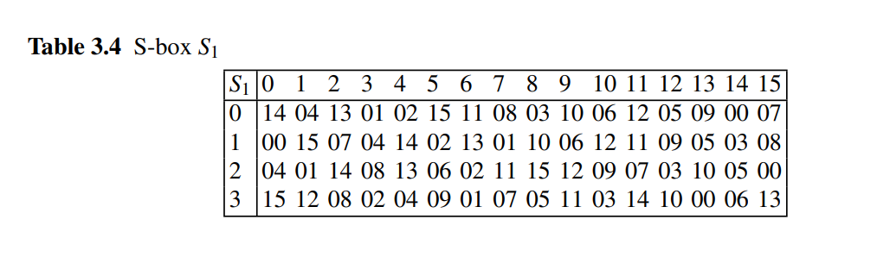

Calculating the S1 for numbers using the above table

1.

$$S_{1}\left(000000\right)⊕S_{1}\left(000001\right)=14⊕0=14$$

$$S_{1}\left(000000⊕000001\right)=0$$

2.

$$S_{1}\left(111111\right)⊕S_{1}\left(100000\right)=13⊕4=1$$

$$S_{1}\left(111111⊕100000\right)=8$$

3.

$$S_{1}\left(101010\right)⊕S_{1}\left(010101\right)=6⊕9=15$$

$$S_{1}\left(101010⊕010101\right)=13$$

**1.3.3 :**

we procced step by step :

initial permutation : after this part text is still all zero

splitting into two parts : first 32 bits bits remain untouched and rest of the bits enter next phase.

calculating f function : first we have to expand our 32 bit input into 48 after this operation we have 48 bits of zeros. after that we do the binary summation on this generated bits and deprived key which leaves us with 48 bits zeros again. in the next step we have to devide these 48 bits by 8 and send each group to one of the S boxes then combine the outputs. output after this part will be 1110,1111,1010,0111,0010,1100,0100,1101 then we have to permute this output using the below table

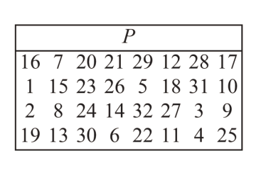

result : 1111,0101,0111,1100,0110,1001,1110,0010

final operation :

in this part first we xor the ouput of f with left part of the input then swap two separated parts. the output will be

0000,0000,0000,0000,0000,0000,0000,0000, 1111,0101,0111,1100,0110,1001,1110,0010

**1.3.5 :**

after initial permutation the new position of our 1 bit will be 33th bit so it takes place in the second half of the whole text. in the next step the text will be expanded which causes us to have 1 on the second and 48th bits so

1. two S boxes(1 and 8) will get different inputs
2. 3 for the first 6 bits and 2 for the last 6 bits 🡪 5bits total
3. 0011,1111,1010,0111,0010,1100,0100,0001 after s boxes 🡪 1011,0101,0010,1100,0010,1001,1111,0010 after permutation
4. due to the previous question 5bits

**1.3.7 :**

1. all subkeys are identical when the key is weak.

2.

$$k_{i+1}=k_{16-i}$$

* alternating ones+zeros(exp: 0x0101010101010101)
* alternating F+E(exp: 0xFEFEFEFEFEFEFEFE)
* 0x(E0E0E0E0F1F1F1 F1)
* 0x(1F1F1F1F0E0E0E0E)

3. =

**1.4.9 :**

8b8a8a8a747575758b8a8a8a74757575

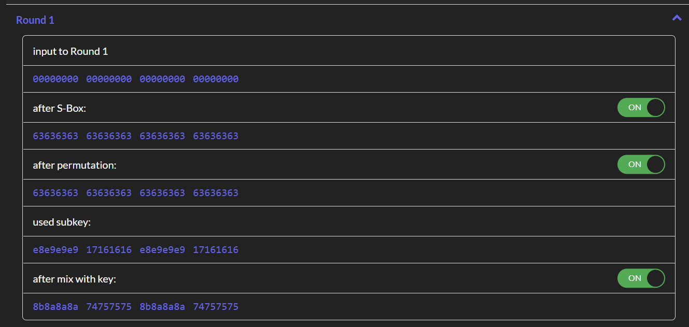

**2:**

1. block ciphers break down the plain text into individual blocks then cipher those blocks bit by bit but stream ciphers cipher the whole plain text bit by bit.
2. to add the confusion feature.
3. since all the process is consist of either permutation which is reversible and xor which we have the $a⨁b=c→a=b⊕c$ then des decryption is indeed reverse of des encryption.
4. AES is stronger against all kind of attacks since has both longer key and more complicated operations.

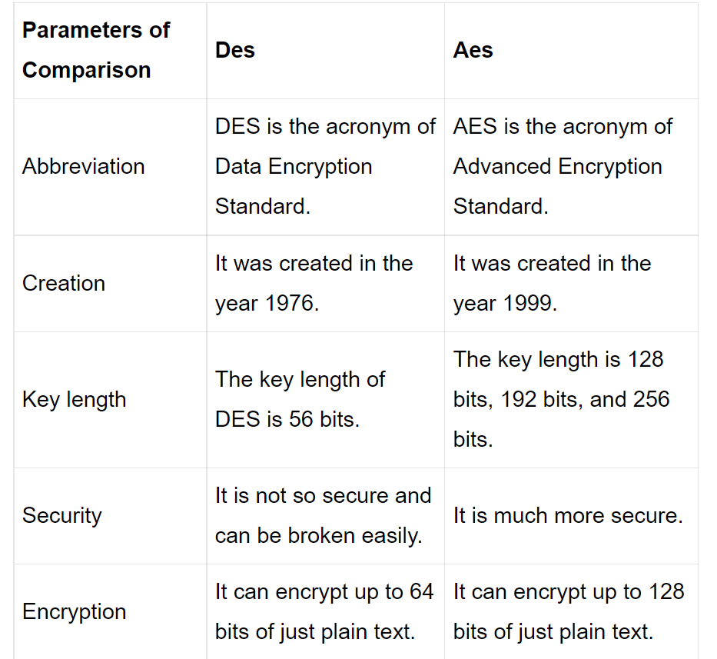

1. Add RoundKey
2. Add RoundKey
3. SubBytes
4. MixColumns
5. ShiftRows

**3.1 :**  key and text : 0000 0001 0010 0011 0100 0101 0110 0111 1000 1001 1010 1011 1100 1101 1110 1111

**attention : we didn’t use initial and final permutations since question hasn’t mentioned it.

a.

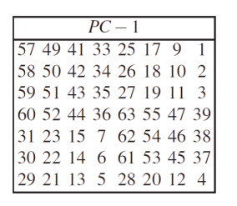

key after PC-1 🡪 1111 0000 1100 1100 1010 1010 0000 0000 1010 1100 1100 1111 0000 0000

here we halve the above bits and rotate left each half by one

key after rotation 🡪 1110 0001 1001 1001 0101 0100 0001 0001 0101 1001 1001 1110 0000 0000

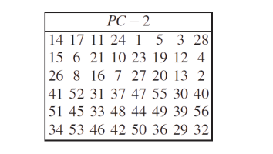

next using PC-2

result 🡪 0000 1011 0000 0010 0110 0111 1001 1001 0100 1000 1010 0101

b. L0=0000 0001 0010 0011 0100 0101 0110 0111R0=1000 1001 1010 1011 1100 1101 1110 1111

c. E(R0)= 1100 0101 0011 1101 0101 0111 1110 0101 1011 1111 0101 1111

d. $E(R_{0})⨁k$ =1100 1110 0011 1111 0011 0000 0111 1100 1111 0111 1111 1010

e. passing through s boxes 🡪 1:1011 2:1000 3:1110 4:1111 5:0110 6:0101 7:0110 8:0011

f.10111000111011110110010101100011

g. applying permutation table 🡪 1000 0000 1101 1111 0011 1111 1100 1110

h. R1🡪 1000 0001 1111 1100 0111 1010 1010 1001

i. final ciphered text 🡪 1000 1001 1010 1011 1100 1101 1110 1111 1000 0001 1111 1100 0111 1010 1010 1001

**4 :**

all of GF(24) irreducible polynomials

$p\left(x\right)=a_{4}x^{4}+a_{3}x^{3}+a_{2}x^{2}+a_{1}x+a_{0}$

since m=4 the $a_{4}$ should be 1 and if also $a_{0}$ should be 1 otherwise it’d be reducible.

for the rest of the coefficients $a_{3}+a_{2}+a_{1}≠0$

final answer:

$x^{4}+x^{3}+x^{2}+x+1$

$x^{4}+x+1$

$x^{4}+x^{3}+1$

**5.1 :**

ciphered text : j5a0edj2b

sample prefix text : WPI

palin text : WPIWOMBAT

**5.2 :**

initialization vector : 1,1,1,1,1,1

**5.3 :**

[1,1,0,0,0,0]

(0,1,6)

**5.4 :**

The common wombat lives mainly in wet, partly forested areas on the coast, and on the ranges and western slopes.

**5.5 :**

Known-plaintext Attack

** the python program is attached as 5_1_LFSR_decoding.py

**6 :**

like 1.3.7 since this key is a weak key, DES becomes a Feistel network and encryption becomes self-inverting so with twice DES encryption using this key we get the plain text itself.

**7 :**

a. text

|  |  |  |  |
| --- | --- | --- | --- |
| 00 | 04 | 08 | 0C |
| 01 | 05 | 09 | 0D |
| 02 | 06 | 0A | 0E |
| 03 | 07 | 0B | 0F |

key

|  |  |  |  |
| --- | --- | --- | --- |
| 01 | 01 | 01 | 01 |
| 01 | 01 | 01 | 01 |
| 01 | 01 | 01 | 01 |
| 01 | 01 | 01 | 01 |

b.

|  |  |  |  |
| --- | --- | --- | --- |
| 01 | 05 | 09 | 0D |
| 00 | 04 | 08 | 0C |
| 03 | 07 | 0B | 0F |
| 02 | 06 | 0A | 0E |

c.

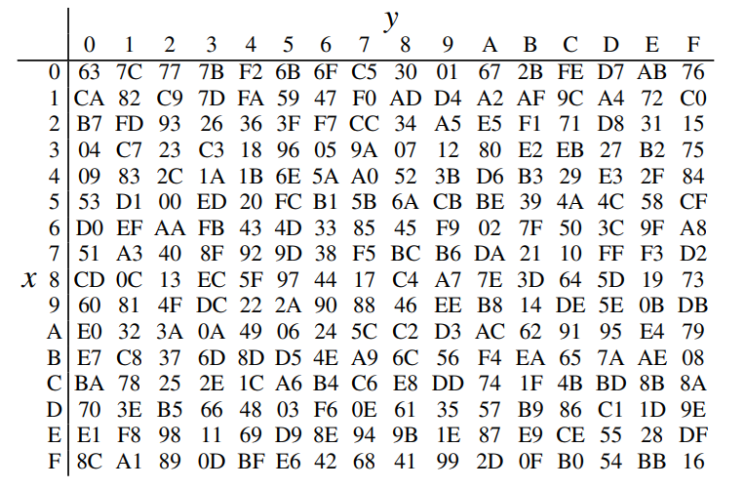

|  |  |  |  |
| --- | --- | --- | --- |
| 7C | 6B | 01 | D7 |
| 63 | F2 | 30 | FE |
| 7B | C5 | 2B | 76 |
| 77 | 6F | 67 | AB |

d.

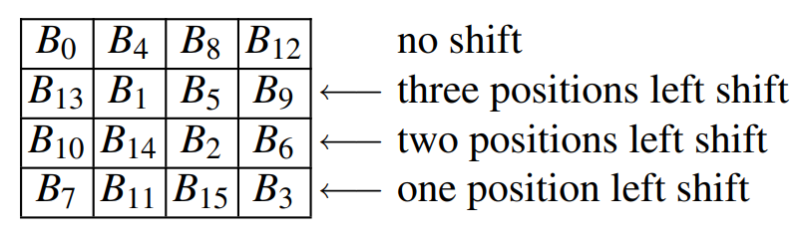

|  |  |  |  |
| --- | --- | --- | --- |
| 7C | 6B | 01 | D7 |
| F2 | 30 | FE | 63 |
| 2B | 76 | 7B | C5 |
| AB | 77 | 6F | 67 |

e.

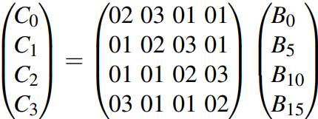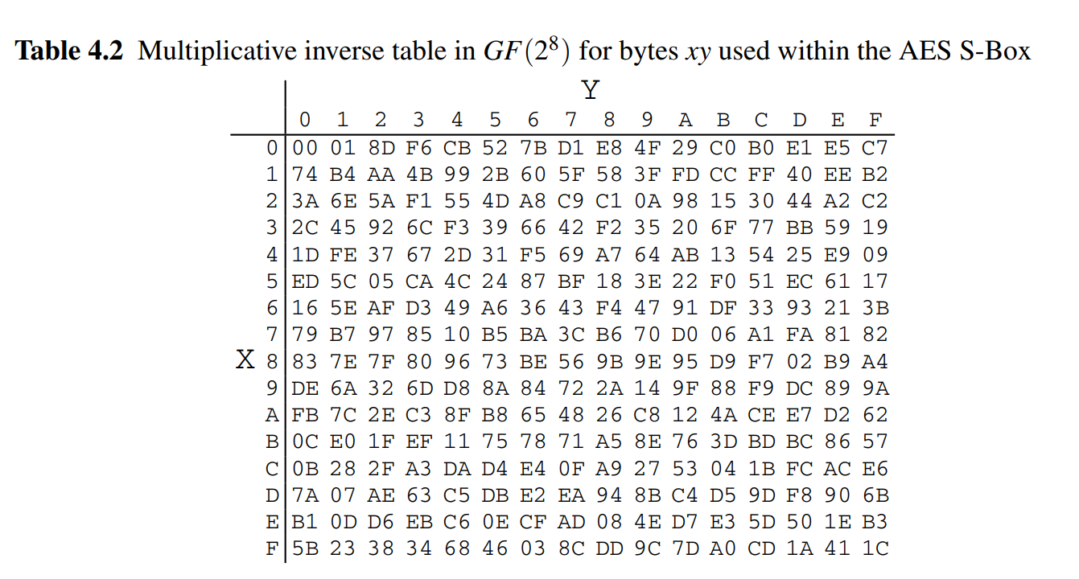

|  |  |  |  |
| --- | --- | --- | --- |
| A1 | DF | 01 | EA |
| 23 | 2C | 41 | D3 |
| 15 | BA | 06 | D4 |
| 4A | 77 | 3C | 43 |

**8.1 :**

weak key : FF FF FF FF FF FF FF FF

first encryption

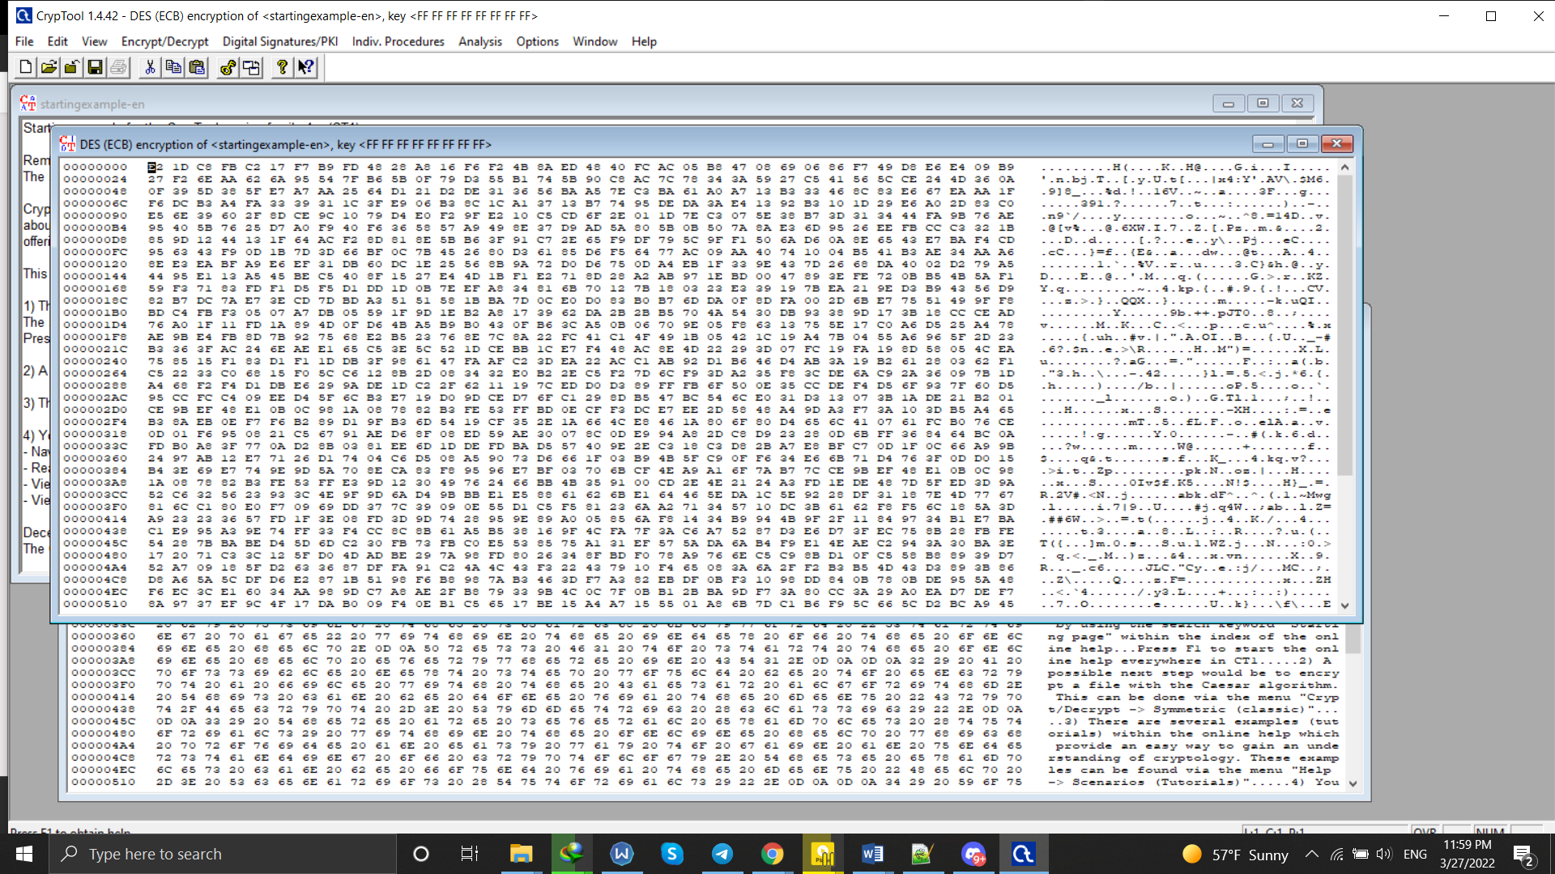

second encryption

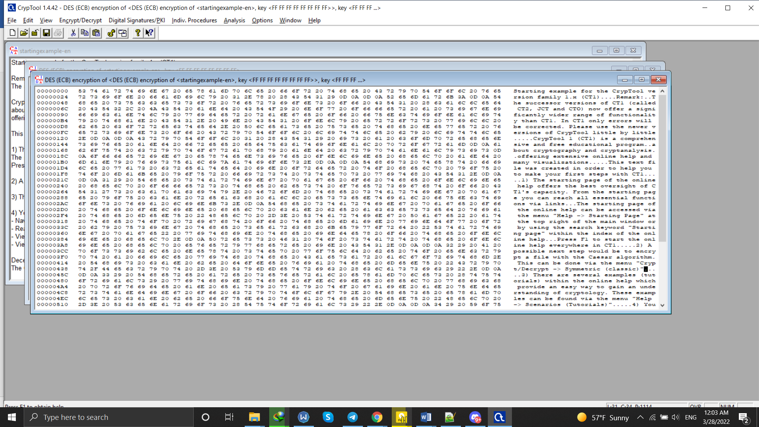

we observe that by encrypting twice we get the plaintext.

semi-weak key : 01 1F 01 1F 01 0E 01 0E

first encryption

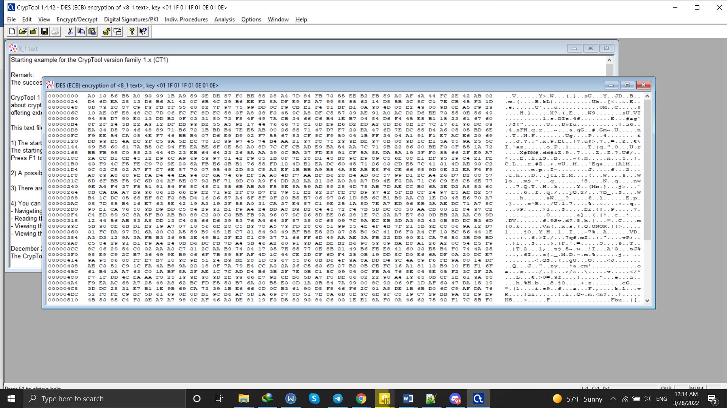

second encryption

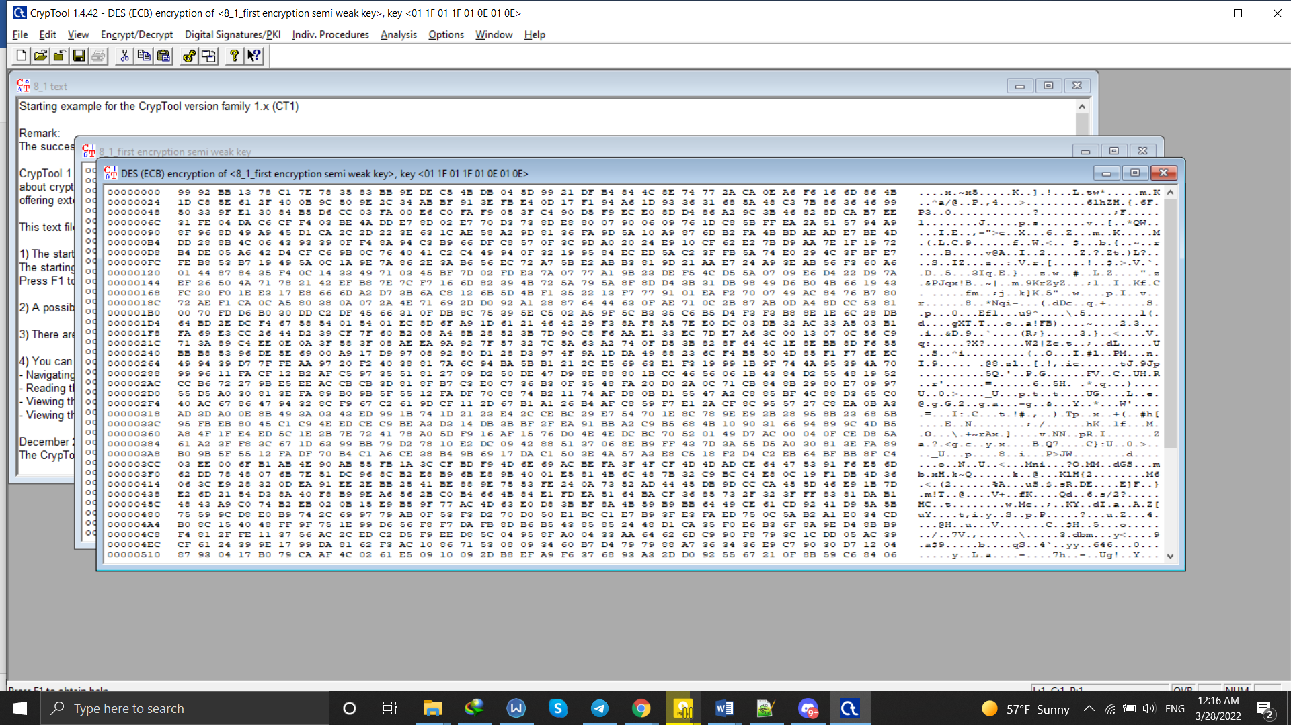

**8.2 :**

i. because it uses three different keys so the search space for the key get increased by a factor of 2 in power.

ii. mentioned in the previous part the reason is a type of attack called meet in the middle which causes us to always get coefficient of key length reduced by 1.

iii. one version does encryption – decryption – encryption and the other one does decryption – encryption – decryption.

if all the keys being independent for brute force attack the power of two is 2*k but if first and third keys are identical then its only k.

iv. key 12 34 56 78 9A BC DE F0 12 23 34 56 78 9A BC ED

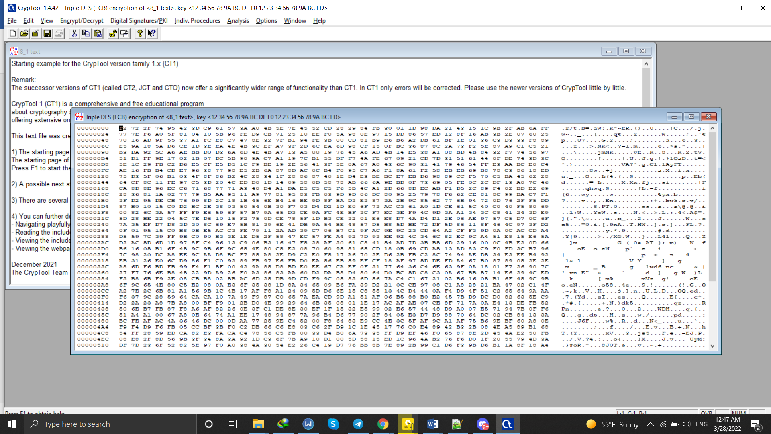

v. k1=12 34 56 78 9A BC DE F0 ,,, k2=12 23 34 56 78 9A BC ED

first time using k1

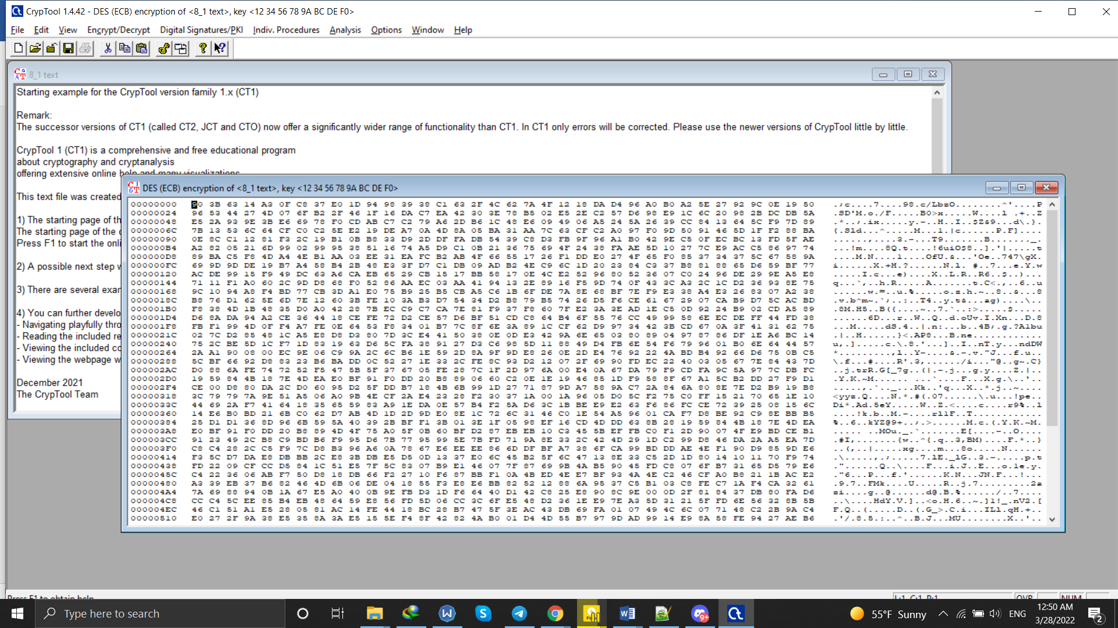

second time using k2

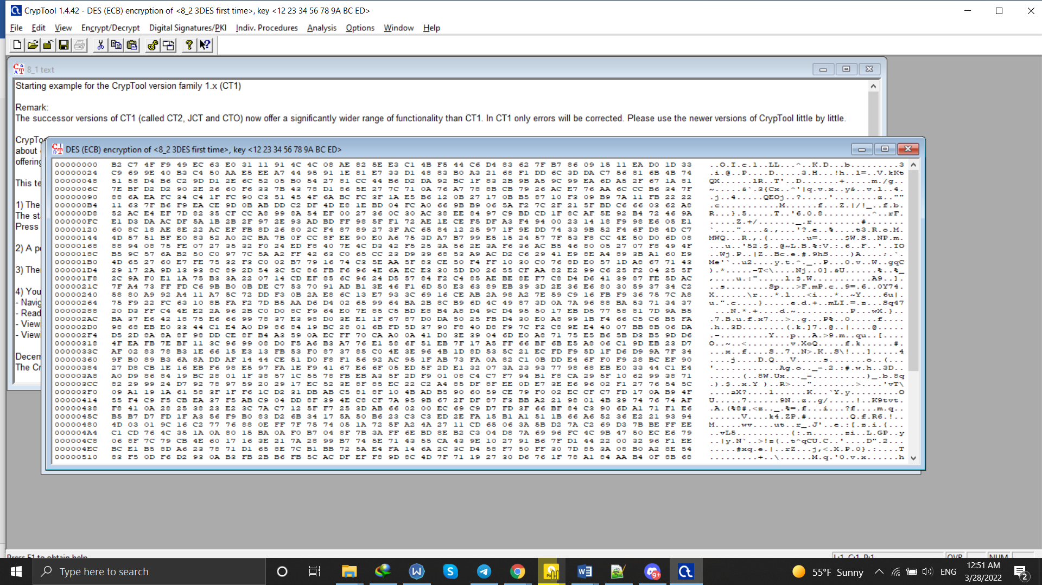

third time using k1

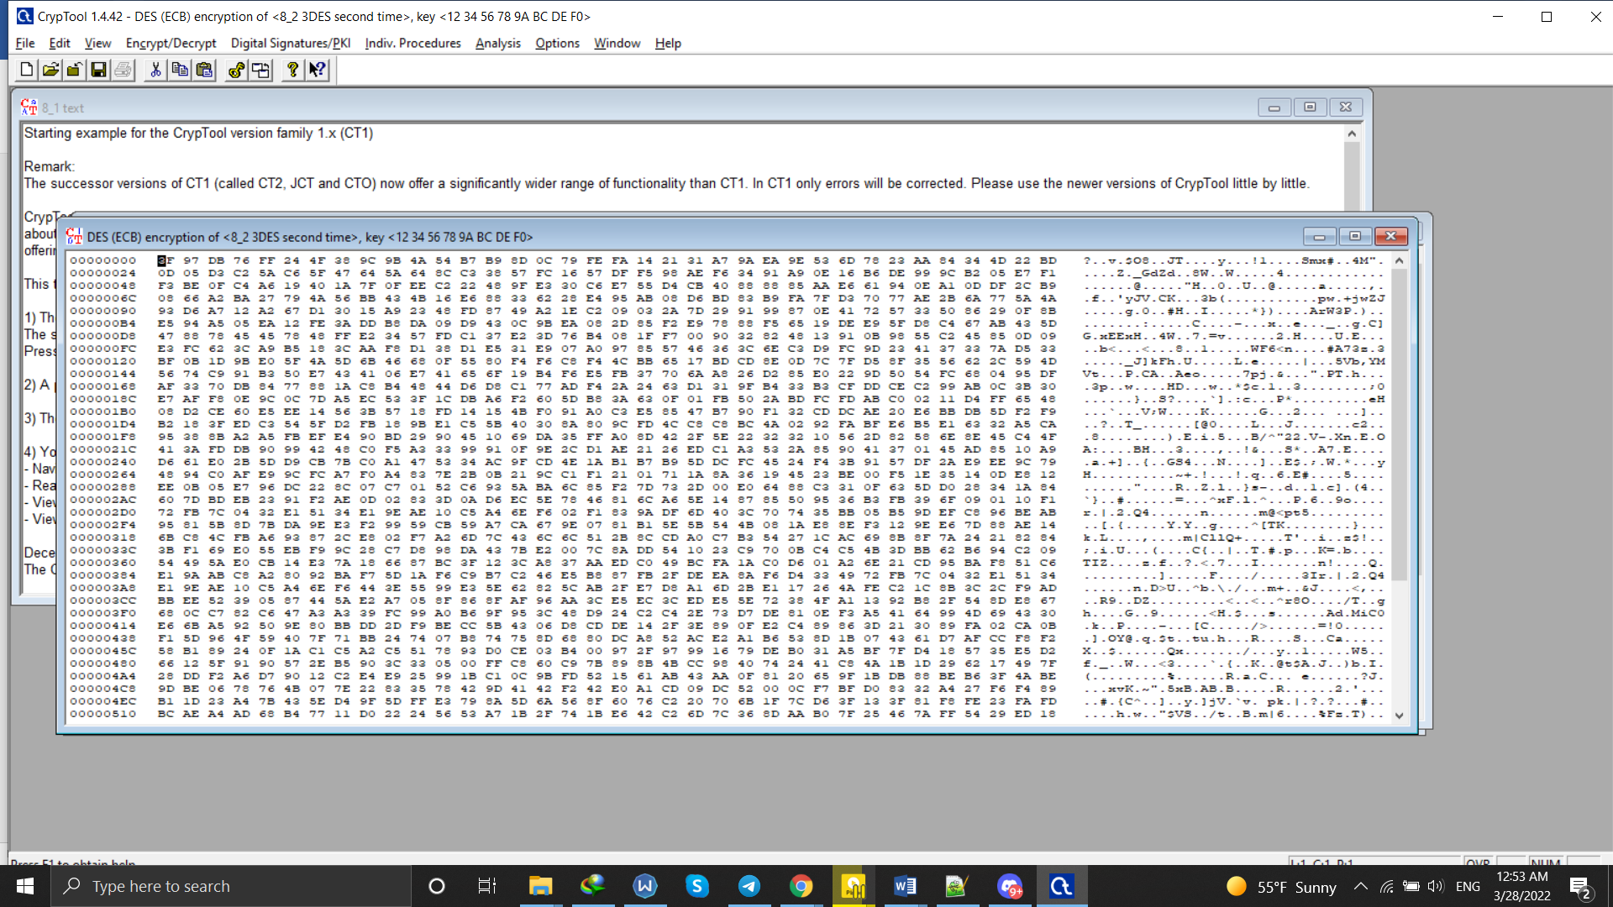

**8.3 :**

i. key 12 34 56 78 9A BC DE F0 12 23 45 55 67 78 88 88 89 AA AB BA AC AE AD FA

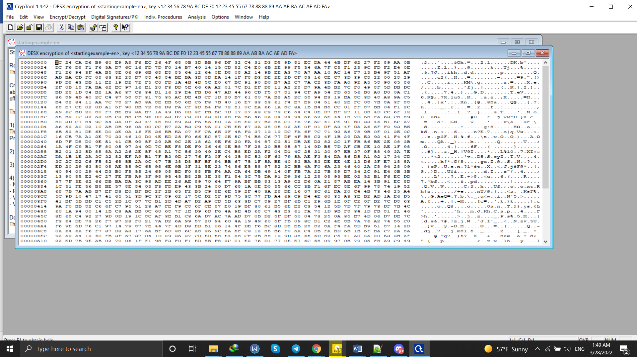

ii. k=12 34 56 78 9A BC DE F0 , k1=12 23 45 55 67 78 88 88, k2=89 AA AB BA AC AE AD FA

k k1

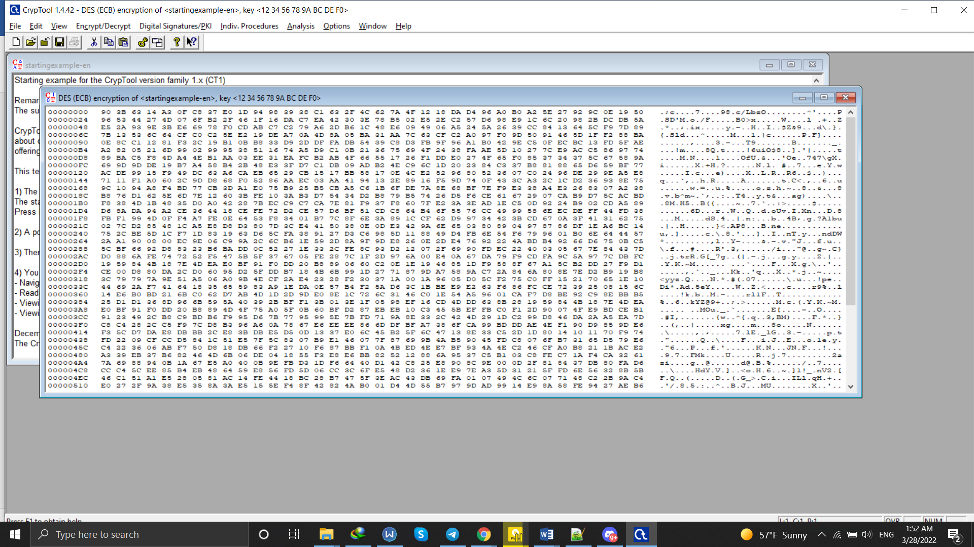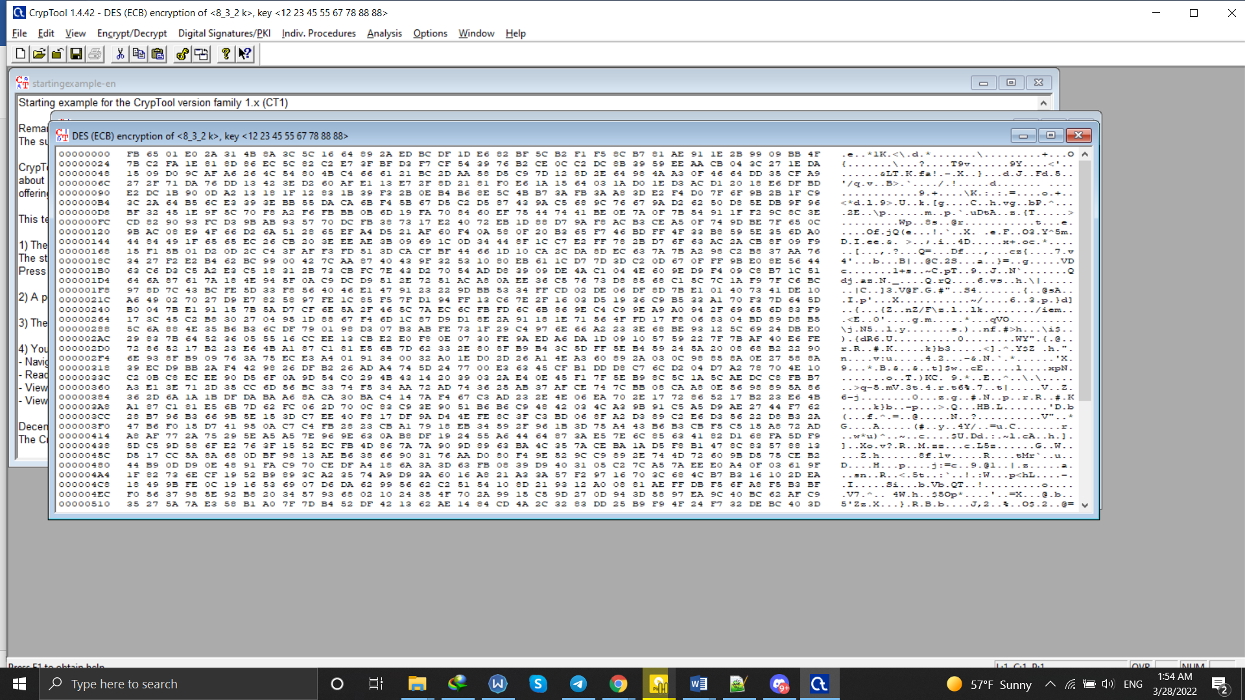

k3

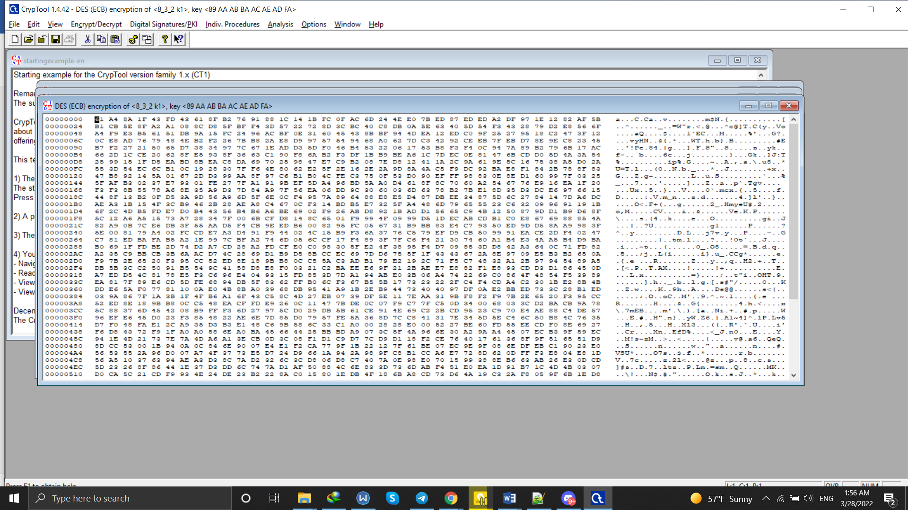

**8.4 :**

key : 12 34 56 78 99 99 AA BB CC CD FE 12 34 56 78 11

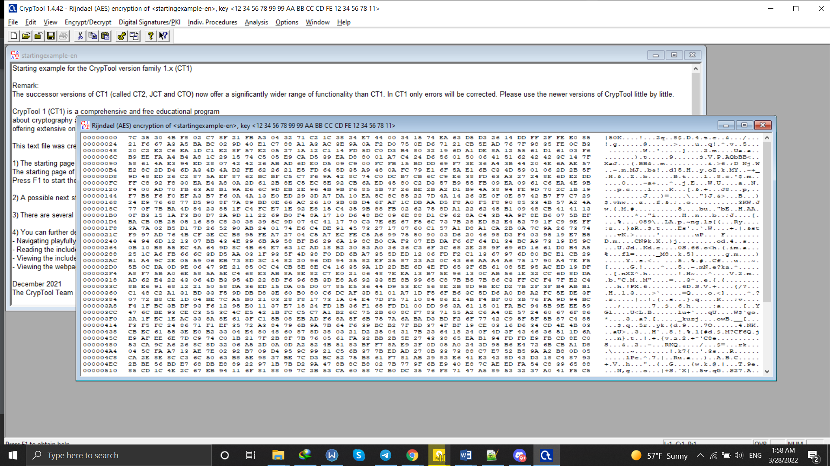

**8.5 :**

i)

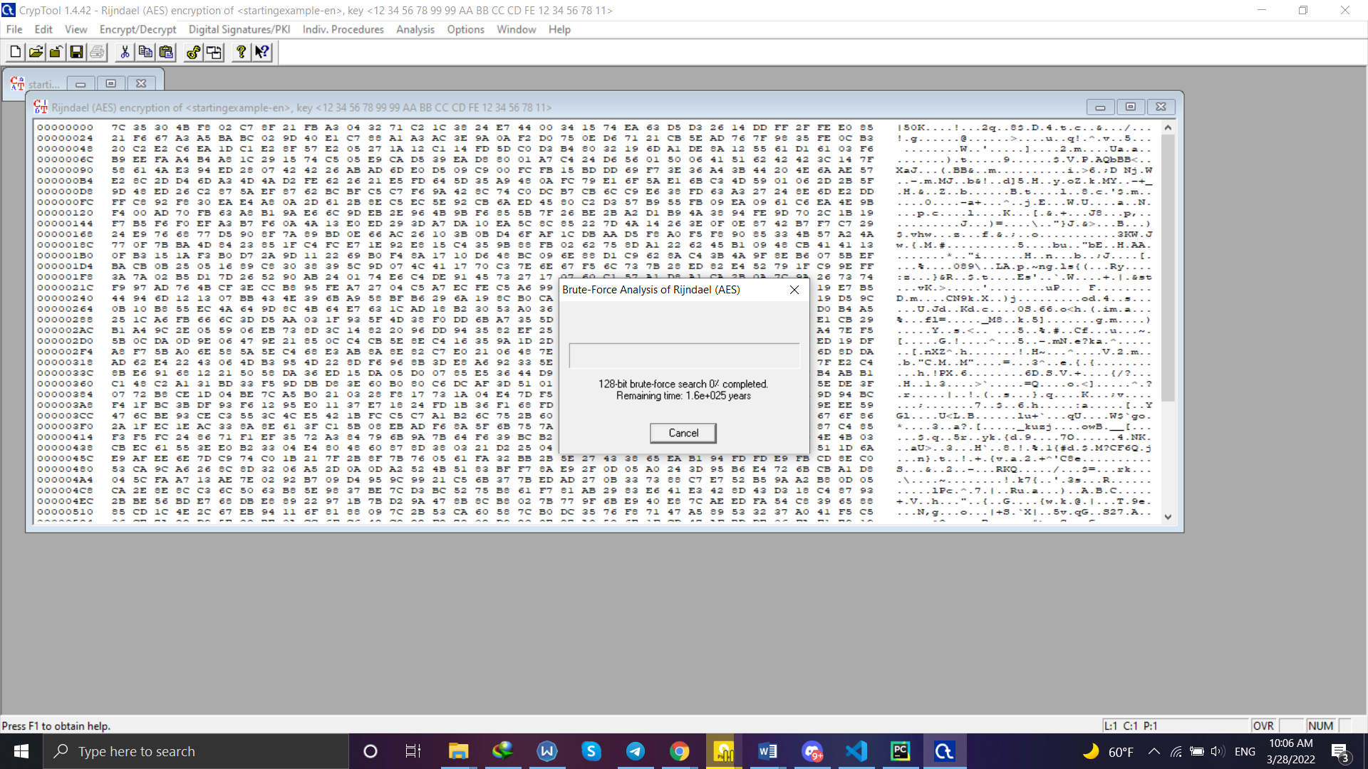

ii) in this part we get the answer immediately